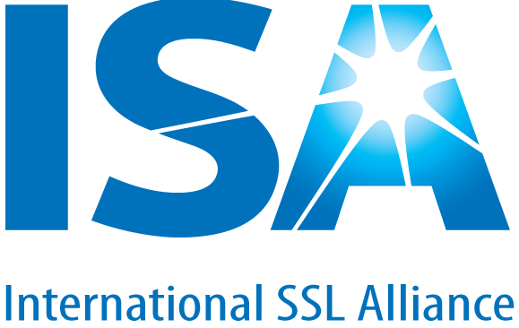

INTERNATIONAL SOLID STATE LIGHTING ALLIANCE
www.isa-world.org

APPLICATION FORM FOR MEMBERSHIP
Please write in English below.

1. Name of the organization: __________________________________________________

2. Address : __________________________________________________

__________________________________________________

Telephone No.: __________________________________________________

Fax No.: __________________________________________________
Mobile No.: __________________________________________________

E-mail __________________________________________________

Website: __________________________________________________

3. Type of organization: Large Enterprise/SME/Academia/Association or Alliance

4. Names of directors: ___________________________________________________

___________________________________________________

___________________________________________________

5. Company registration No.: _____________________________________________ ______

6. Location of operation: ___________________________________________________

7. Please fill in where applicable,
Enterprises: products manufactured/marketed
Academia: major research area
Association or Alliance: a brief introduction of your association

_____________________________________________________________________________________

_____________________________________________________________________________________

_____________________________________________________________________________________
8. No. of employees: ___________________________________________________

9. If your organization is an enterprise, please fill in turnover of the last year: _________ USD

10. Reasons of participating in ISA and expectations

_____________________________________________________________________________________

_____________________________________________________________________________________

_____________________________________________________________________________________

_____________________________________________________________________________________

Note: Once this application being approved by ISA Council of Management you are the formal member of ISA. You are subjected to pay your annual membership fee on time according to the ISA policy. The ISA Secretariat will inform you on your membership fee in due time.

Membership fee: 14000RMB/year or 2000USB/year.

Date

Signature

Please complete the form and return it to:

Mr. He Yang
Executive Secretary
International SSL Alliance
Secretariat Address: Room 1305, Block 2D, Zhongguancun IC Park, No. 9 Fenghao East Road, Haidian District, Beijing
Tel: +86-10-62607585
Fax: +86-10-62607258
Email: yanghe@isa-world.org
Visit us at www.isa-world.org

For Chinese Members
入会补充信息
（请中国企业填，中文填写）

1、 | 公司中文名称
2、 | 公司主要领导（1-2个）  及其E-mail、电话 | 姓名： 职务  E-mail： 手机号码：
2、 | 公司主要领导（1-2个）  及其E-mail、电话 | 姓名： 职务  E-mail： 手机号码：
3、 | 公司地址  （可用于日常邮寄）
4、 | 日常工作联系人  （最好填写两位） | 姓名： 职务  E-mail： 手机号码：  传真：  姓名： 职务  E-mail： 手机号码：  传真：
5、 | 业务领域介绍

For Foreign Members
Additional information on Membership Application
1、 | Organization Name
2、 | Main leaders (2) | Name： Title：  E-mail： Tel No.：
2、 | Main leaders (2) | Name： Title：  E-mail： Tel No.：
4、 | Daily work contact (2) | Name： Title：  E-mail： Tel No.：  Fax：  Name： Title：  E-mail： Tel No.：  Fax：
5、 | Introduction of Business Field

